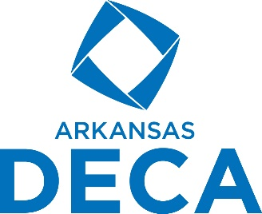
NWA Fall Leadership Conference Testing Results
Individual Exams based on Individual Written Scores
September 28, 2022
Hospitality & Tourism Written Exam

Mady Cartwright, 1st
Brianna Belt, 2nd
Dinesh Vasireddy and Anna Fryer tied for 3rd
Randal (Aunyx) Rogers, 4th
Caitlyn Swopes, 5th
Emelia Bell, 6th

Marketing Written Exam

Blake Honchell, 1st
Leah Telgemeier, 2nd
Katie Jones, Blake Holsted and Lidia Morales, tied for 3rd
Sophia Weidner, 4th
Chase Stanton, 5th
Chase Homsley, 6th

Personal Finance Written Exam
Carley Sexton, 6th
Jace Keller, 5th
Haden Rankin and Kaleb Taylor, tied for 4th
Kelsey Jung, 3rd
Landon Gadberry, 2nd
Lance Pollard, Placing, 1st
Business Administration Core Written Exam

Kaylee Coble, 1st
Nora Shitandi, 2nd
Jack Snell, 3rd
Christopher Huber, 4th
Kaushal Dhumal, 5th
Kathy Do, 6th

Business Mgmt & Admin Written Exam

Akshaj Tadiparthi, 1st
Rodrigo Suarez Lopez Gallo, 2nd
Saloni Satappagol and Pablo Fajardo, tied for 3rd
Liliana Olan, 4th
Kallista Herndon and Santiago Gurrola, 5th
Laci Cox and Blake Ellis, tied for 6th

Finance Written Exam

Alberto Linares Mercado, 1st
Ashley Sexton, 2nd from Fayetteville
Ashley Sexton, 3rd from Harrison
Owen Hale, 4th
Bennett Eubanks, 5th
Vanessa Aldana, 6th

Entrepreneurship Written Exam

Hanna Hicks, 1st
Elaina Whiting, 2nd
Sarah DellaCroce, Ethan Arnsperger, and Ella Williams, tied for 3rd
Case Enderland, 4th
Lillyanna Gigerich, 5th
Alyssa Viccaro, 6th

